ETL PROJECT REPORT

**Topic:**

**Contributors:**

Trending YouTube Videos

Firdaus Mehta

Natalie Manahan

Sreemanth Gurram

Table of Contents

Objective………………………………………………………………………………………………3

Problem Statement…………………………………………………………………………………….3

Extract Transform Load (ETL) Diagram……………………………………………………………...3

Data Clean-up and Analysis

Step 1 : Extraction……………………………………...……………………………………...3

Step 2 : Transforming………………………………………………………………………….4

Step 3: Loading………………………………………………………………………………..4

Resources……………………………………………………………………………………………...4

Objective

The objective of this report is to provide a detailed analysis of the ETL (Extract-Transform-Load) process by interpreting a dataset of Trending YouTube videos, obtained from Kaggle, cleaning the dataset in the desired form and loading it into a database for storage.

Problem Statement

Observe trending YouTube videos across the United States and Great Britain along with the dataset of various categories they belong to. Perform an ETL on the datasets that can be uploaded into production to determine which categories or videos are most or least popular, depending the on number of views, likes, dislikes, and comments.

ETL Diagram

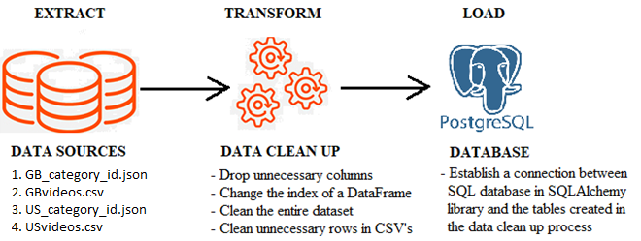

Data Clean-up and Analysis

**Step 1: Extraction**

The dataset is a daily record of the top trending YouTube videos. Data is included for the CA, DE, FR, GB, IN, JP, KR, MX, RU, and US regions. The focus of this report will be on the US and GB regions. Each region’s data is in a separate file and includes the video title, channel title, publish time, tags, views, likes and dislikes, description, and comment count. The data also includes a category_id field, which varies between regions and the categories for a specific video are in the associated JSON for that region. The data has been downloaded from the public platform Kaggle[5]. The files used for extraction were originally formatted as .csv and .json, which are then read into a Pandas data frame in Jupyter notebook.

**Step 2: Transforming**

* First, read the GBvideos.csv[2] and USvideos.csv[4] into Pandas data frames; videoGB_df and videoUS_df, using read_csv.
* Drop the columns that are not relevant from the data frames by selecting the columns. The columns to keep and analyse are video_id, title, category_id, publish_time, views, likes, dislikes, comment_count into a new_videoGB_df and new_videoUS_df.
* In the new data frames, rename the columns publish_time and comment_count to ‘publish_datetime’ and ‘comments’ respectively.
* Next, drop the duplicated video titles drop_duplicates().
* Read the US_category_id.json[3] and GB_category_id.json[1] into a Pandas data frame, US_ category_df and GB_category_df, using read_json().
* Extract the category_id and category_title from the item column of the category_df, because of the way the JSON files are structured.
* From category_df the item column is stored in a list format. Iterate over the list to extract and store the id and title in separate lists which are used in defining a new data frame, new_category_df.
* Merge the new_videoGB_df and new_videoUS_df separately with the new_category_df on category_id and store them into a new data frame, mergedGB_df and mergedUS_df. A country column was added to each, storing “GB” and “US”.

**Step 3: Loading**

Use a relational d relational database, such as Postgres SQL to load the data. Then establish a connection between SQL database youtube_video_db using create_engine() in the SQLAlchemy library. Load the data frames in the tables created; video_GB, video_US, category, video_category_GB, and video_category_US to be used for production.

Resources

1. <https://www.kaggle.com/datasnaek/youtube-new?select=GB_category_id.json>
2. <https://www.kaggle.com/datasnaek/youtube-new?select=GBvideos.csv>
3. <https://www.kaggle.com/datasnaek/youtube-new?select=US_category_id.json>
4. <https://www.kaggle.com/datasnaek/youtube-new?select=USvideos.csv>
5. <https://www.kaggle.com/datasnaek/youtube-new>